Slocum Flight Simulations on NAGA1 and NAGA2

Pat Welch

Oregon State University

16-July-2023

The code for this is available at <https://github.com/mousebrains/GliderFlightSimulator>

This work uses data supplied by Javier for his ROMS simulations off Vietnam for 2013-01-01 through 2022-12-31.

I have a “simplistic” glider simulator which steps from surfacing to surfacing, calculating a depth averaged current from Javier’s data. I also include a surface drift. The simulation was run for each day in the ROMS dataset, except for the final 30 days, 2013-01-01 through 2022-12-01. This is 3600+ simulations in each direction for a set of initial conditions.

There are three navigation models:

1. Fly a constant heading, either +90 to fly east to west or +270 to fly west to east.
2. Use current correction models to fly to the end point. This is equivalent to a single waypoint the glider is flying towards.
3. Try and stay on the line. The priority is staying on the line, not making headway. So sometimes the glider gets blown the wrong way. (This would require shoreside dynamic generation of waypoint files.)

The flight parameters were:

* Pitch = 26 degrees
* AOA = 2.5 degrees
* dzdt is the vertical speed (0.1m/s is “normal”, 0.2m/s is high speed, and 0.3m/s is thruster speed)
* horizontal speed = dzdt/tan(pitch + AOA)
* Number of yos between surfacing, 3

Known weaknesses include:

* No latitude dependence in the ROMS data.
* No stochastic behavior is included anywhere.
* No compass inaccuracies are included.
* The bathymetry is not used, so on the shelf the glider’s depth in simulation is shallower than it would be in reality.

**NAGA1 East to West at a constant heading of +270 degrees:**

Please note that the glider can be blown eastward, even when using the thruster.

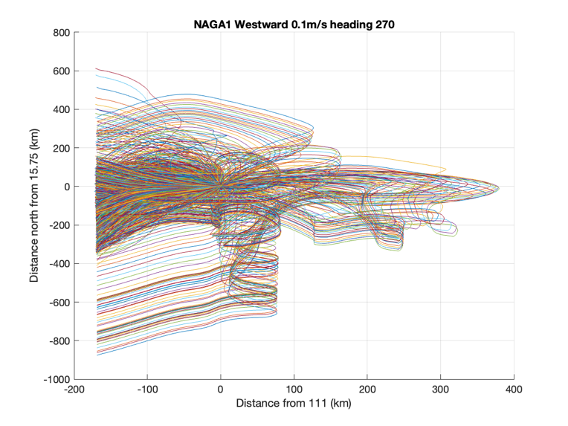

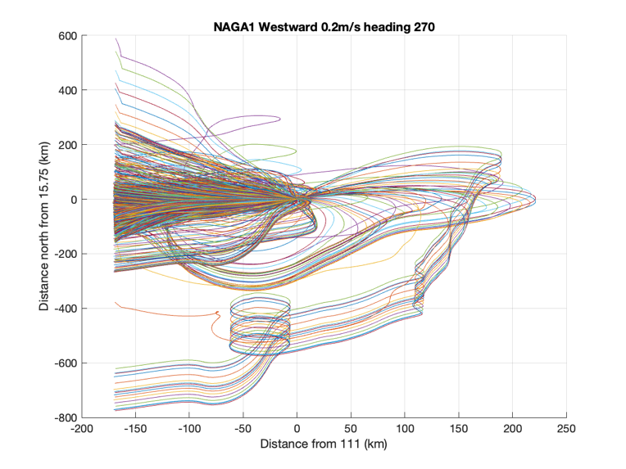

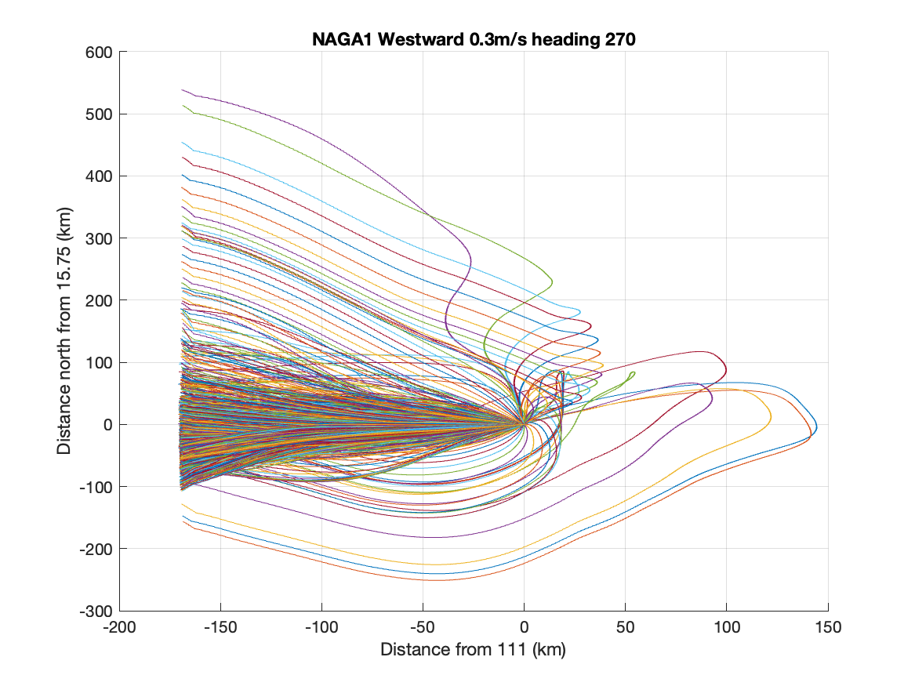

**NAGA1 West to East at a constant heading of +90 degrees:**

Please note that the glider gets blown onto shore with a vertical dive speed of less than 0.2m/s.

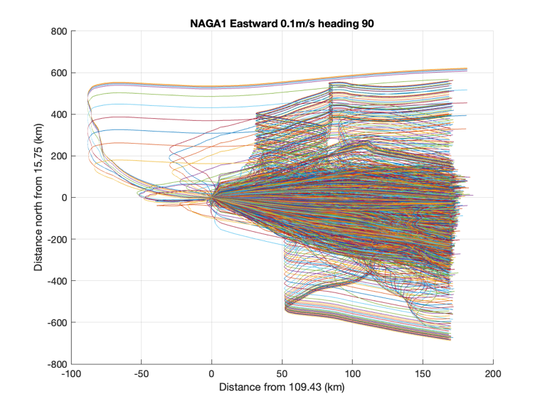

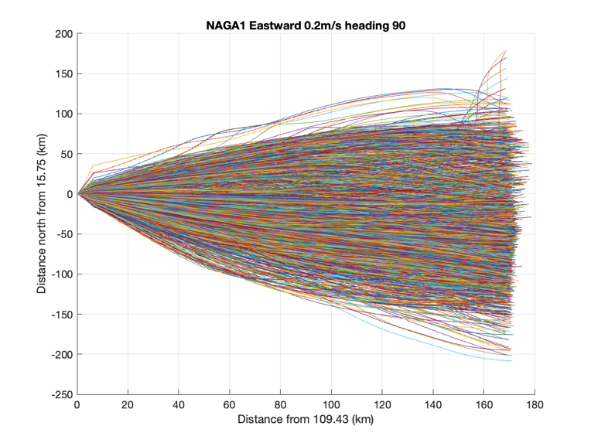

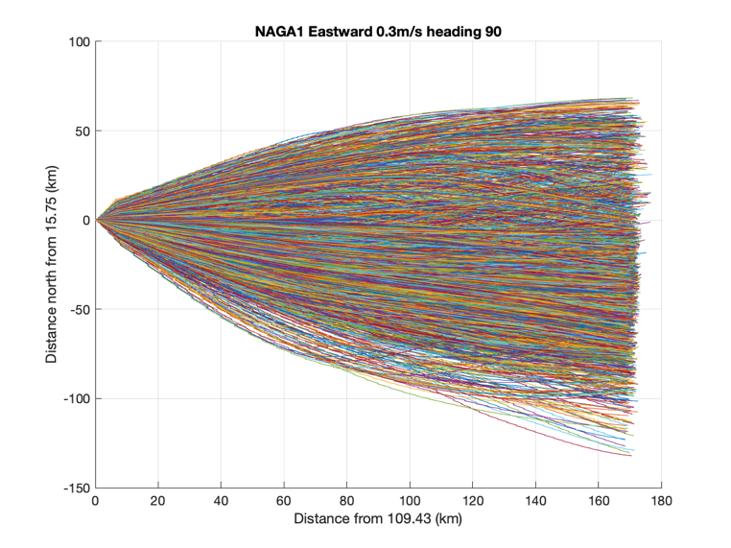

**NAGA1 East to West using current correction:**

Please note that the glider can be blown eastward, even when using the thruster. Also when the glider is on the shelf it is blown southwards.

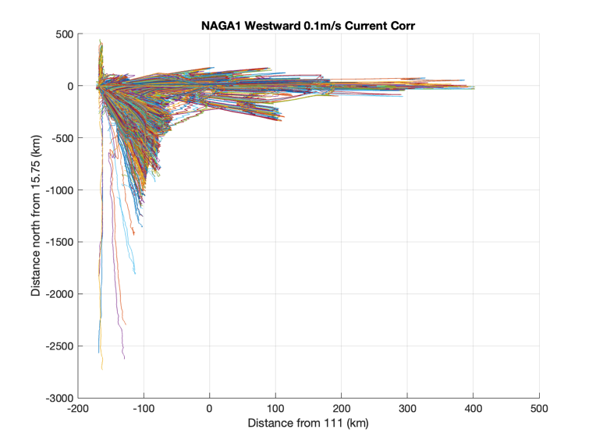

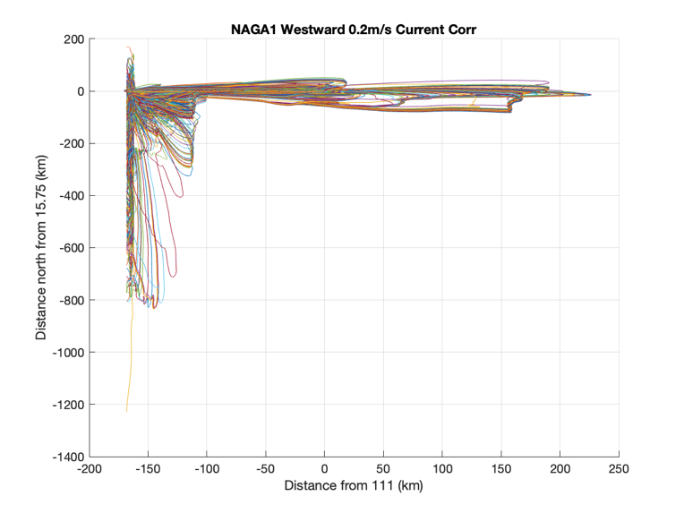

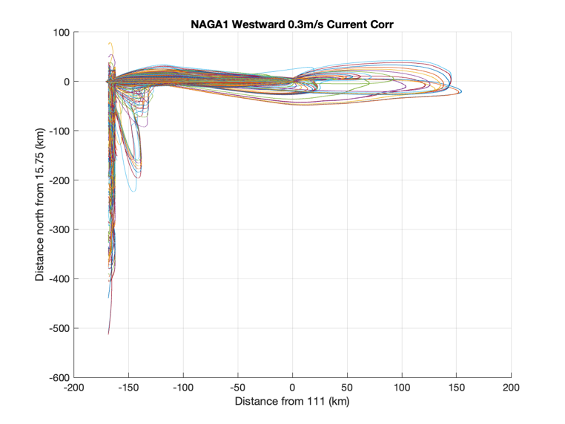

**NAGA1 West to East using current correction:**

Please note that the glider gets blown onto shore with a vertical dive speed of less than 0.3m/s. With the thruster, other than one day, the glider was able to stay within ±50km.

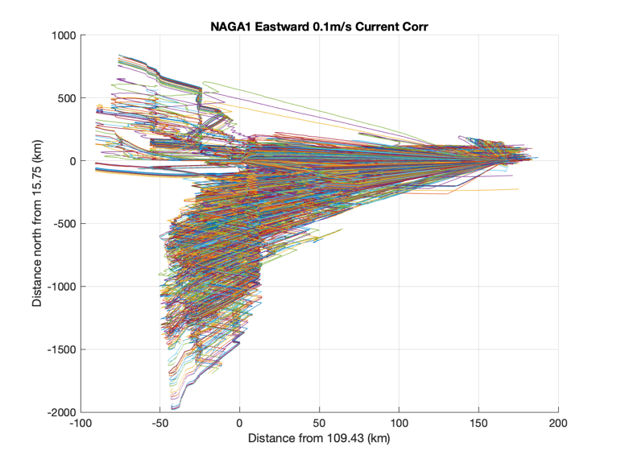

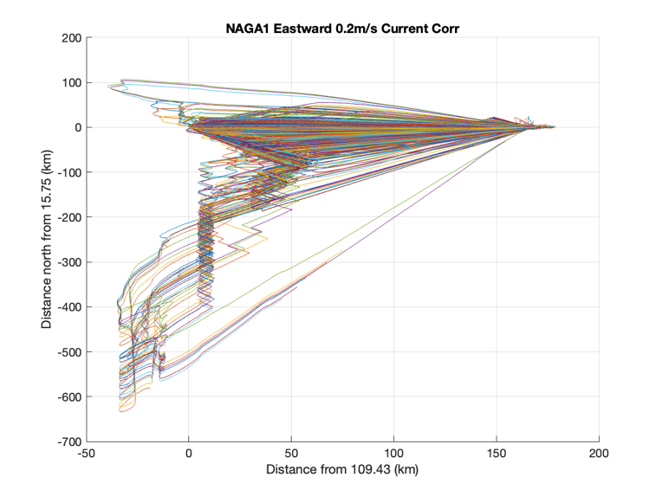

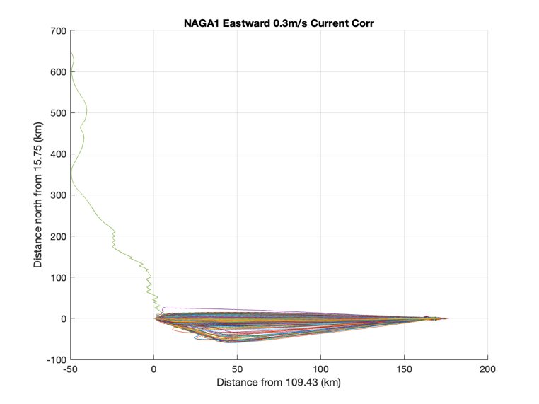

**NAGA1 East to West flying to the line of longitude:**

Please note that the glider can be blown eastward, even when using the thruster. With at least 0.2m/s vertical speed, the glider is on the line until it gets near the shelf.

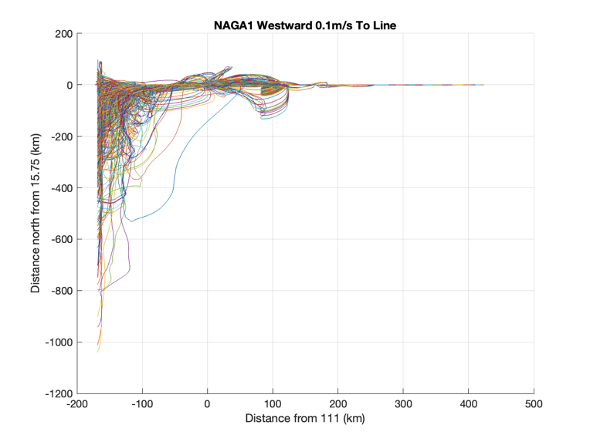

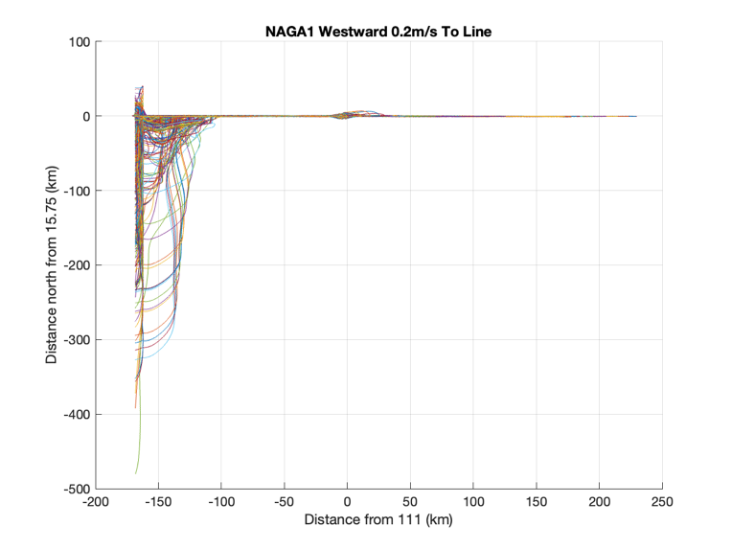

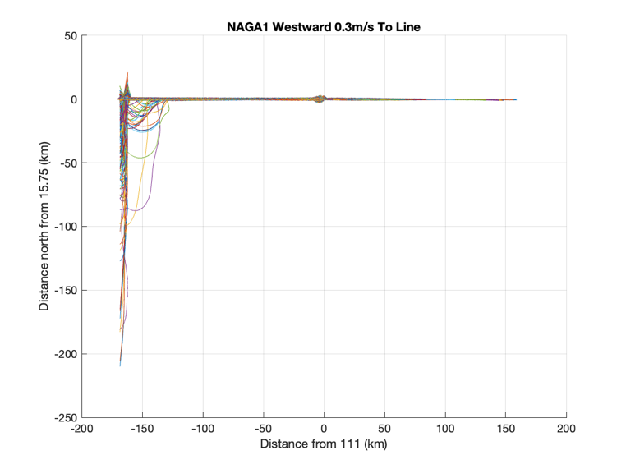

**NAGA1 West to East to the line of longitude:**

Please note that the glider commonly gets blown onto shore. Given the priority is flying to the line, not making headway, the glider spends a lot of time on the shelf.

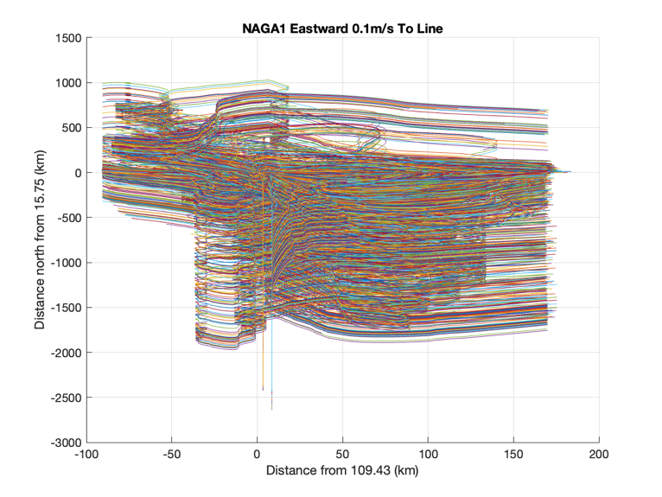

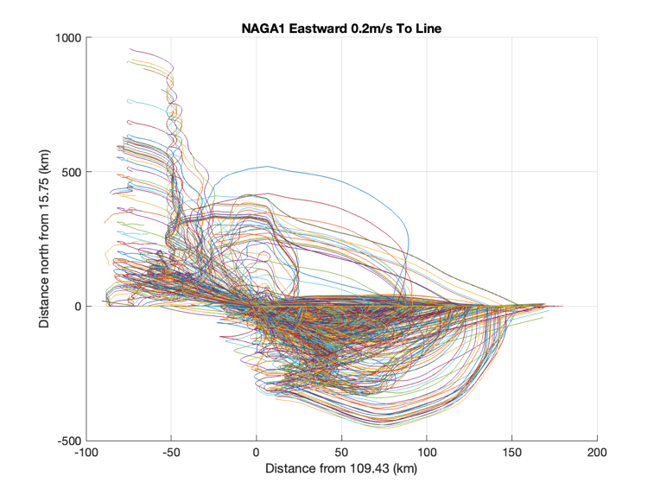

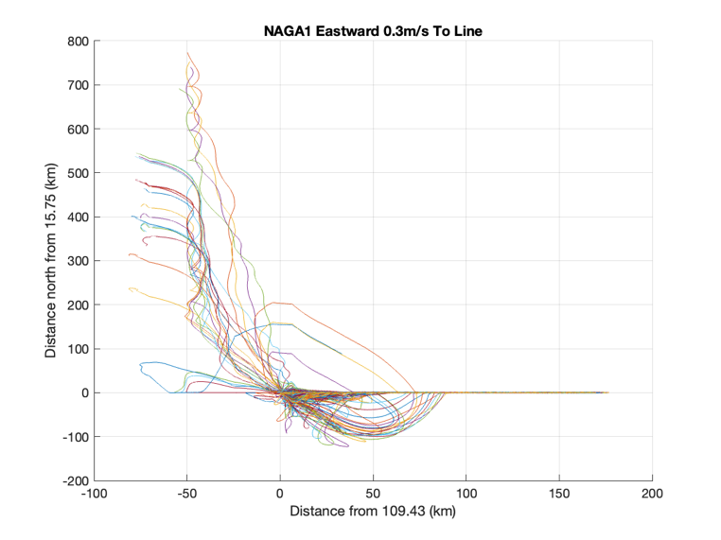

**NAGA2 East to West at a constant heading of +270 degrees:**

Please note that the glider can be blown eastward, even when using the thruster.

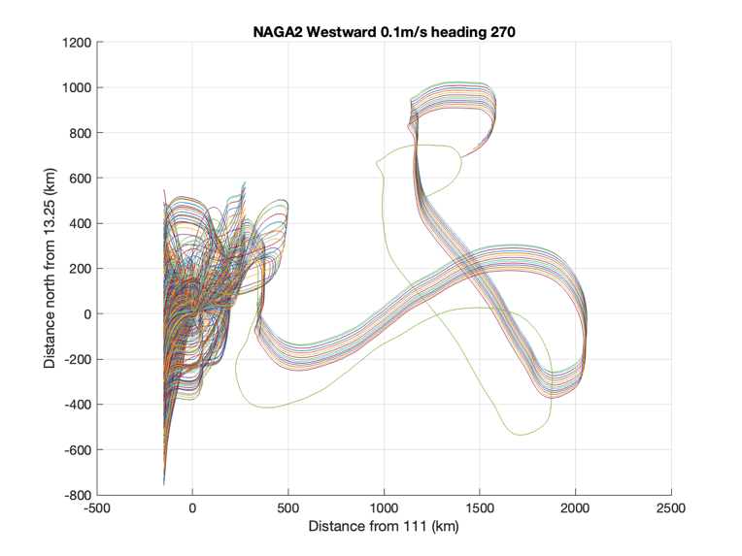

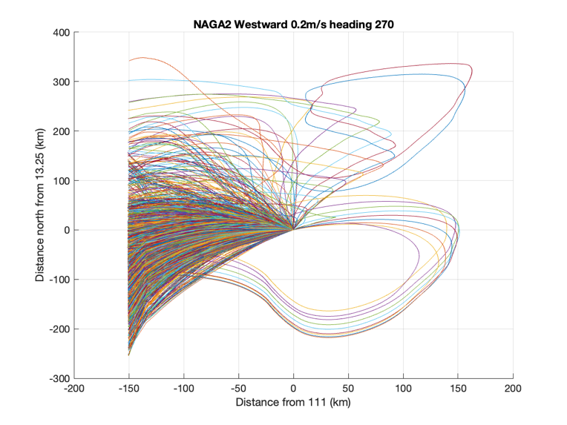

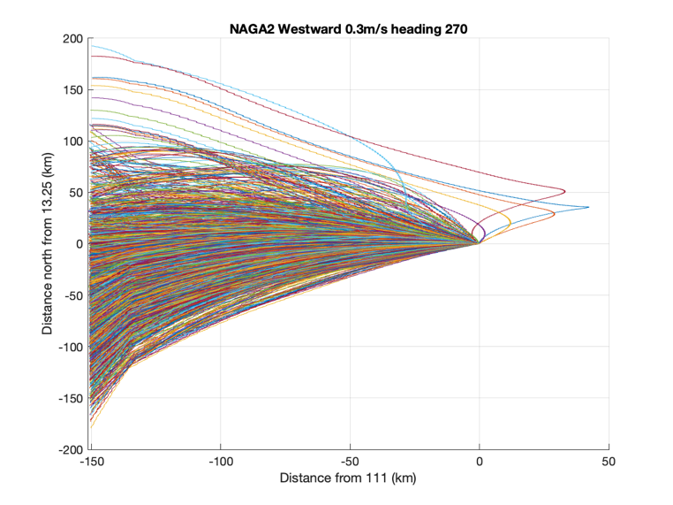

**NAGA2 West to East at a constant heading of +90 degrees:**

Please note that the glider can be blown onto shore with a vertical dive speed of less than 0.2m/s.

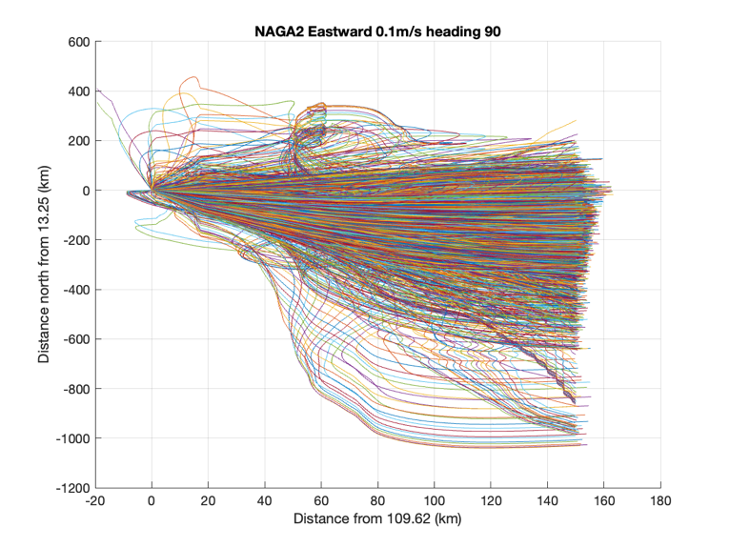

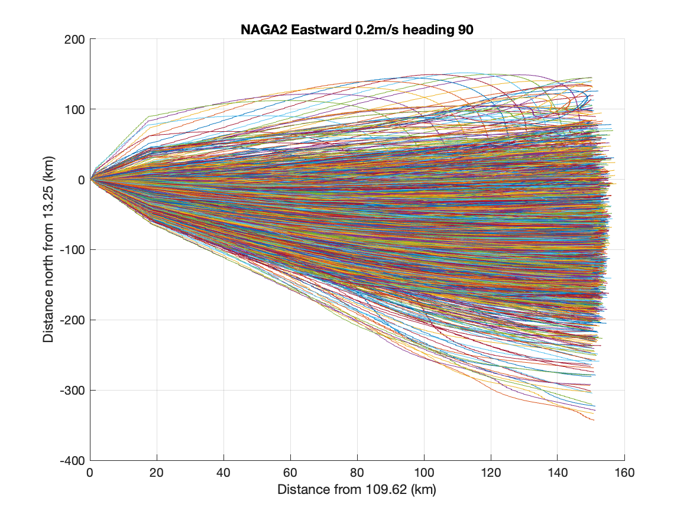

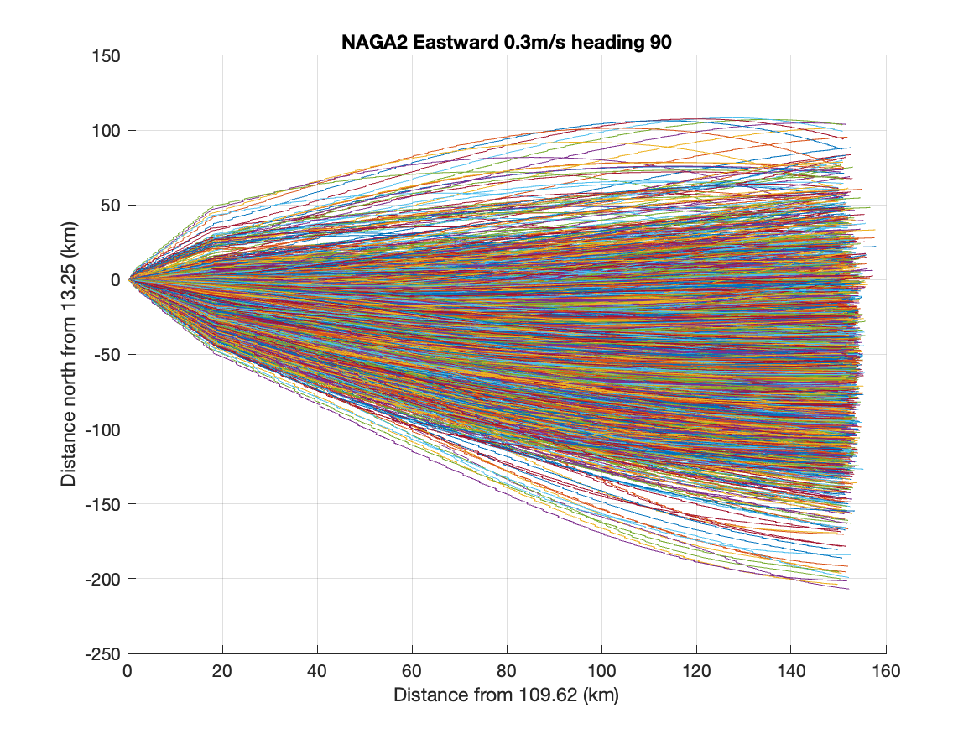

**NAGA2 East to West using current correction:**

Please note that the glider can be blown eastward, even when using the thruster. Also when the glider is on the shelf it is blown southwards.

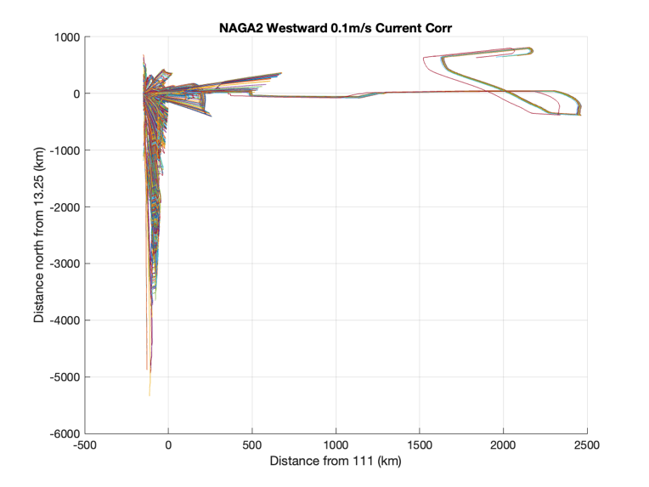

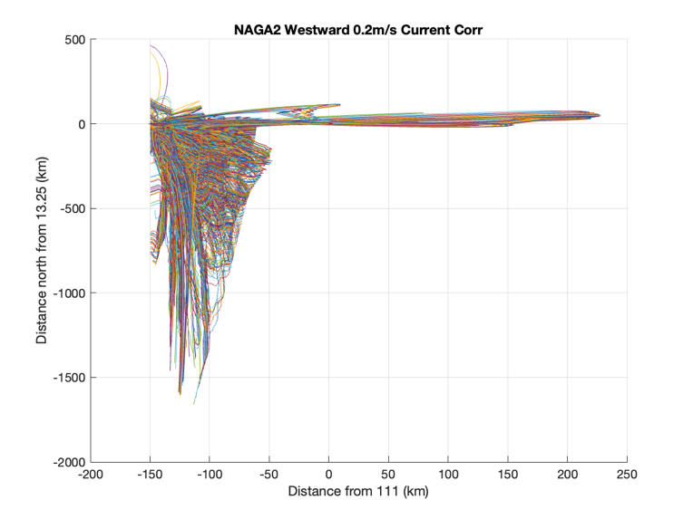

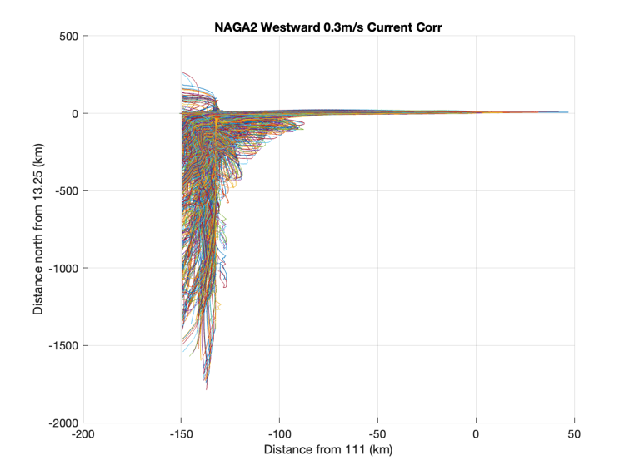

**NAGA2 West to East using current correction:**

Please note that the glider can be blown onto shore. Near the shelf the glider is blown southward, then converges to the eastern waypoint.

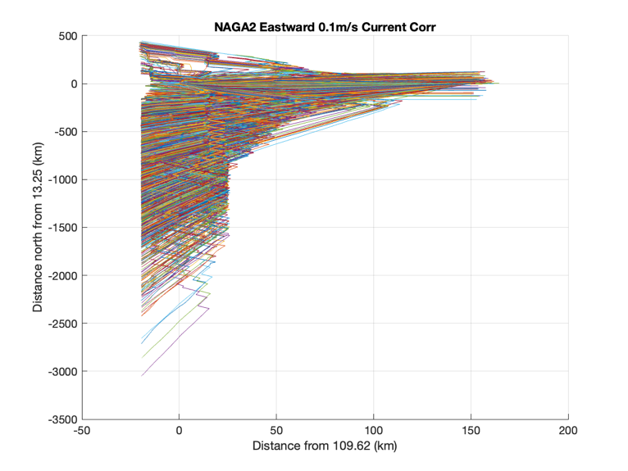

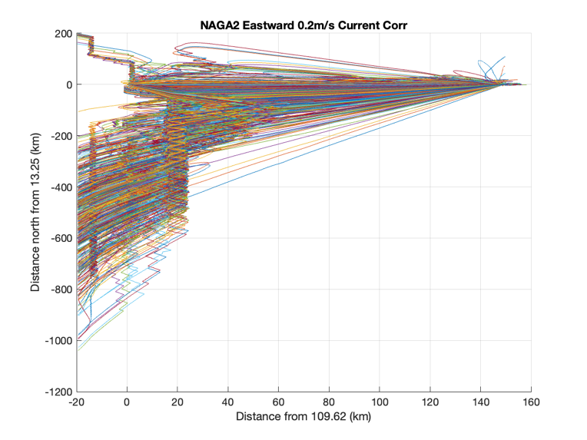

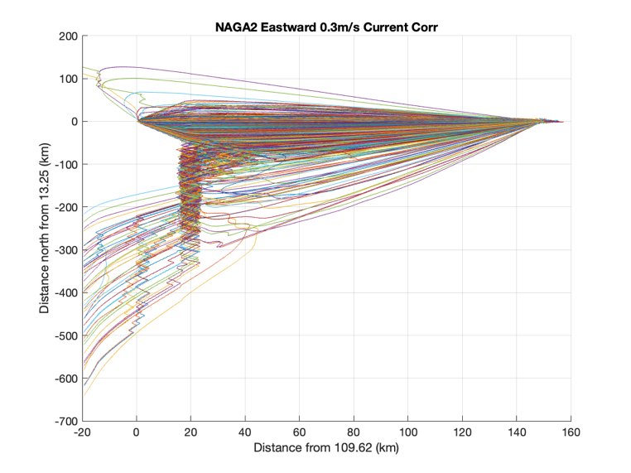

**NAGA2 East to West flying to the line of longitude:**

Please note that the glider can be blown eastward, even when using the thruster. With at least 0.3m/s vertical speed, the glider is on the line until it gets near the shelf.

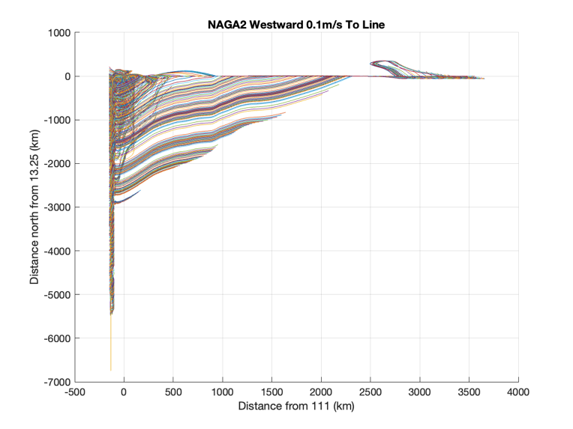

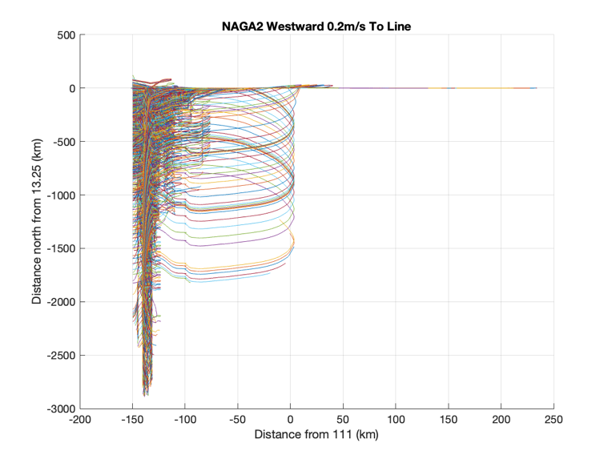

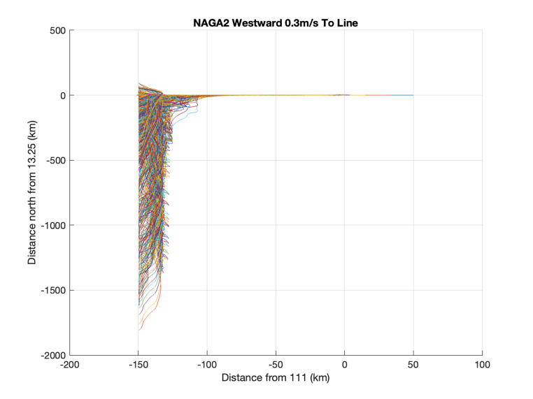

**NAGA2 West to East using current correction:**

Please note that the glider commonly gets blown onto shore. Given the priority is flying to the line, not making headway, the glider spends a lot of time on the shelf.



